***Enterprise Chat System***

Installation Instructions V1.0

Date: 14-05-2017

**Team Name:**

**Wireshark**

**Team Members: -**

1. **Ginka Anusha**
2. **Gurram Karthik**
3. **Hossen Saddam**
4. **Injeti Ravi Varma**
5. **Ivvala Venkata Sai Krishna Chaitanya**
6. **Kadamati Venkata Sai Sidhartha**
7. **Karumanchi Mahesh Chowdary**
8. **Kondepati Divya Naga Krishna**
9. **Kovvuru Nasirali**

**10.Sathi Santhosh Reddy**

**11.Janagam Anirudh**

**Type of Document:** Installation instructions

**Version Number :**1.1

**Publication Date:** May 14th, 2017

**1.Preface:**

Aim of this project is to develop an Enterprise Chat System such that the employees of Xtreme Security can communicate safely. This document is organised such that it shows step-by-step procedure to install the applications and run it.

**Release version v1.1**

* Changes are made in section 4 : Connection between the servers and switch is explained with the help of UML diagram.

**Release version v1.0**

Initial release

Remainder of the document is organised as follows:

* **Section 2:** Glossary and abbreviations used in the document
* **Section 3:** Shows the steps to set-up the application and configure it.
* **Section 4:** Shows the installation instructions of the source code.

**2.Glossary and Abbreviations:**

**SQL**: Standard Queuing Language.

**IP ADDRESS**: Internal Protocol Address.

**PHP:** Hypertext Pre-processor

**HTML:** Hyper Text Mark-up Language

**JSON:** JavaScript Object Notation

**REST:** Representational State Transfer

**API:** Application program interface

**MYSQL:** An open source relational database management system

**3. XAMPP Application set-up :**

**XAMPP** is a free and open source cross-platform web server solution stack package developed by Apache Friends, consisting mainly of the Apache HTTP Server, MariaDB database, and interpreters for scripts written in the PHP and Perl programming languages.

* 1. **How to install and run XAMPP in windows:**
* Go to the Apache Friends website and download XAMPP.
* The XAMPP file is 109MB. Once downloaded, launch the installer.
* During the install process, you may receive warnings such as Windows asking you if you’re sure you want to install the software and the installer prompting you about antivirus software. As you would when be installing any software on Windows, use your best judgment, but you probably want to click “Yes” to continue with the install.
* The XAMPP setup wizard will guide you through the installation. Click **Next**
* Next, select the folder where you would like to install XAMPP on your machine. I’m going to create a new folder in **C:\Program Files\XAMPP**.
* After going through all those initial installation steps, XAMPP is now finally ready to install. Click **Next**.
* Once installed, you’ll be asked whether you would like to start the XAMPP Control Panel, which provides an interface for running your localhost environment. Leave this option ticked and click **Finish**.
* Start the XAMPP Control Panel.
* Start the Apache and MySQL components. You can also start the other components, if you plan to use them.
* Verify the Apache install, by clicking on the Apache administrative link in the Control Panel. Verify the MySQL installation, by clicking on the MySQL administrative link in the XAMPP Control Panel.
* If the verification steps are successful, XAMPP should be successfully installed on your PC. Open a browser and enter "localhost" on your address bar. You will be redirected to a page telling you that you've successfully installed xampp on your systemNow open a browser and type the following url :<http://localhost/phpmyadmin> . XAMPP server is ready to use.

**3.2 How to install and run XAMPP in Linux:**

* **Download the XAMPP installer.** You can get it from apachefriends.org/download.html Make sure to download the correct version for your system (32-bit or 64-bit).
* **Open the Terminal** and type cd Apps/
* Before you can install XAMPP, you'll need to change the permissions for the downloaded file so that it can be executed.
* **Change the permissions.** Enter the following command and press Enter, entering your password if required:

sudo chmod +x xampp-linux-x64-5.6.3-0-installer.run

You can drag the downloaded file into the Terminal window to automatically enter the file name and location.

* **Run the installer.** After changing the permissions, you can run the installer to begin installing XAMPP. Type the following command and press Enter:

sudo ./xampp-linux-x64-5.6.3-0-installer.run

* **Start the XAMPP service.** You can start XAMPP using the Terminal by entering the following command and pressing Enter. You may be prompted for your password.

sudo /opt/lampp/lampp start

* **Open the XAMPP splash page in your web browser.** Open your web browser and type in http://localhost/xampp/ in your address bar. If the XAMPP service is running, you'll see the Welcome page. This will help you test that XAMPP is running correctly.
  1. **How to install and run XAMPP in MAC :-**
* Download XAMPP for Mac OSX - Be sure to select the proper version of PHP. For Webucator classes, any version after 5 will be fine.
* Open the downloaded file (the DMG-Image).
* Drag and drop the XAMPP folder into your Applications folder.
* Starting XAMPP on OSX
* To start XAMPP simply open **XAMPP Control** (by going to /Applications/XAMPP/XAMPP Control in **Finder**) and start Apache and MySQL.
* Open your web browser and type in http://localhost/xampp/ in your address bar. If the XAMPP service is running, you'll see the Welcome page. This will help you test that XAMPP is running correctly.

**4. How to run the source code :**

* Source code is available in zip file.
* Extract the zip file.
* Import the source codes into the htdocs of the XAMPP folder.
* Create a database using the folder mysql and import the tables into it.
* The product source codes can be run by connecting users and admin by using a switch to the server.
* The product can be run from any device by typing the url in the web browser

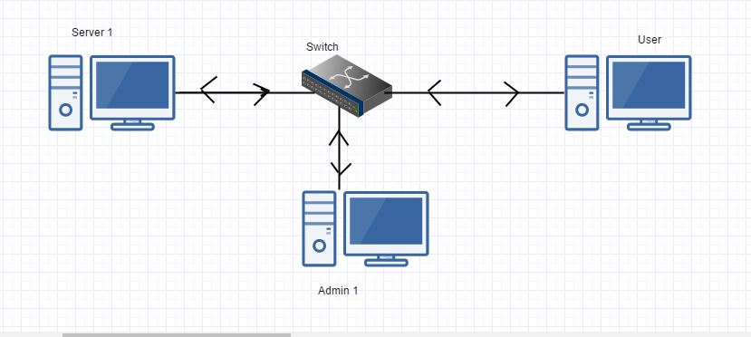

* Above diagram clearly explains the connection between different servers , admin and users using a switch and Cables .